We run a preorder depth-first search (DFS) on the root of a binary tree.

At each node in this traversal, we output D dashes (where D is the depth of this node), then we output the value of this node.  If the depth of a node is D, the depth of its immediate child is D + 1.  The depth of the root node is 0.

If a node has only one child, that child is guaranteed to be **the left child**.

Given the output traversal of this traversal, recover the tree and return *its* root.

**Example 1:**

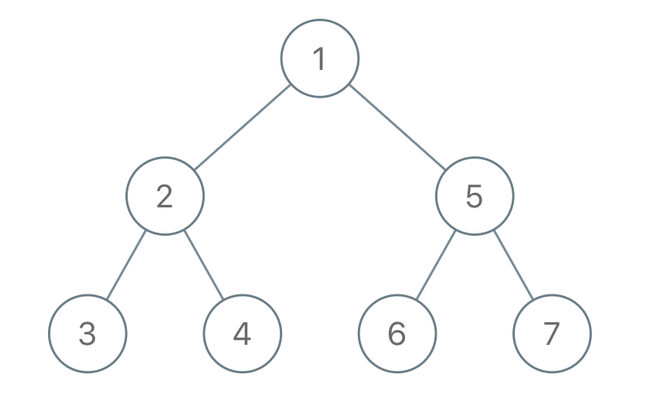

Input: traversal = "1-2--3--4-5--6--7"  
Output: [1,2,5,3,4,6,7]

**Example 2:**

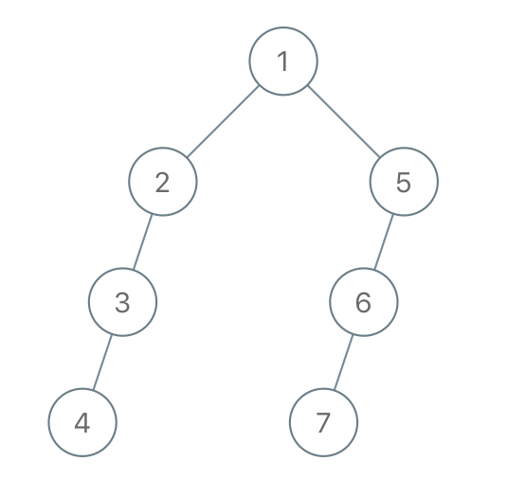

Input: traversal = "1-2--3---4-5--6---7"  
Output: [1,2,5,3,null,6,null,4,null,7]

**Example 3:**

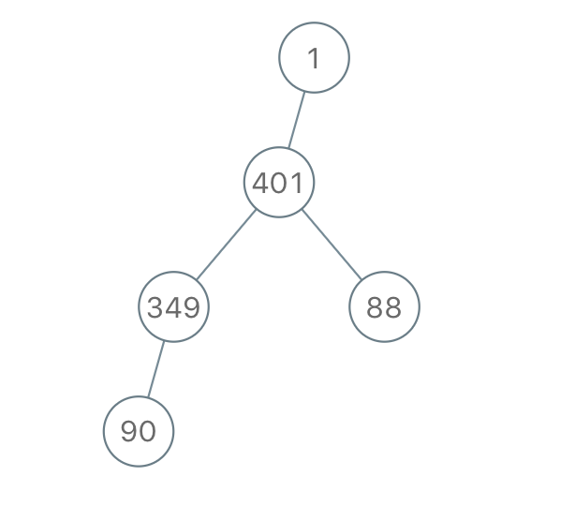

Input: traversal = "1-401--349---90--88"  
Output: [1,401,null,349,88,90]

**Constraints:**

* The number of nodes in the original tree is in the range [1, 1000].
* 1 <= Node.val <= 109